Jonathan Masukawa (33128396) Yan Zhao (31018809) Group #32

The analysis from the algorithms makes sense and the results are expected.

FCFS - This algorithm has relatively even wait/response/turnaround time

RR - This algorithm has the lowest response time, but high wait/turnaround time

Priority - This algorithm has average wait/response/turnaround due to the randomization and even distribution of data; priority is as good as FCFS if the priorities don't relate to any other properties of the data. The preemptive version has lower response but higher wait/turnaround.

SJF (non-pre) - This algorithm has the lowest average wait of non-preemptive algorithms, as expected. This results in low response times as well, but is an unfair algorithm.

SJF (pre) - This algorithm has the lowest average wait of all algorithms, and results in lower response times and wait times compared to its non-preeemptive counterpart.

**Extra Credit**

ML - This multi-level algorithm (RR10, RR20, FCFS) provides low response time, but at the cost of high wait/turnaround times. The response time is higher than RR but the wait/turnaround time is lower.

ML2 - This multi-level algorithm (SJF, RR10, RR20) provides lower wait/turnaround times compared to ML, and ML2-pre has lower values for all three performance metrics than ML-pre. The advantage of using an algorithm that implements SJF in its first layer ensures that small processes are finished quickly, while negating the low response time that SJF can achieve if a process is starved via the RR 2nd and 3rd queues. If a time-based aging system is implemented with this algorithm, the large quantum used for the 3rd queue would help ensure that processes that have been around for a longer time are allowed to finish more quickly than processes that are younger, minimizing extreme values of turnaround time that can result from neglected processes.

Jonathan Masukawa (33128396) Yan Zhao (31018809) Group #32

|  |  |  |  |  |  |  |  |  |
| --- | --- | --- | --- | --- | --- | --- | --- | --- |
| **First Come First Serve** | | | |  | **Round Robin (equal time)** | | | |
|  | **Wait** | **Response** | **Turnaround** |  |  | **Wait** | **Response** | **Turnaround** |
| **Min** | 0 | 0 | 7 |  | **Min** | 0 | 0 | 7 |
| **Mean** | 159.17 | 159.17 | 195.01 |  | **Mean** | 269.32 | 9.75 | 305.17 |
| **Max** | 345 | 345 | 381 |  | **Max** | 968 | 40 | 1049 |
| **StdDev** | 101.99 | 101.99 | 104.03 |  | **StdDev** | 220.25 | 8.41 | 229.93 |
|  |  |  |  |  |  |  |  |  |
| **Priority (non-preemptive)** | | | |  | **Priority (preemptive)** | | | |
|  | **Wait** | **Response** | **Turnaround** |  |  | **Wait** | **Response** | **Turnaround** |
| **Min** | 0 | 0 | 7 |  | **Min** | 0 | 0 | 7 |
| **Mean** | 154.31 | 154.31 | 190.15 |  | **Mean** | 200.28 | 82.61 | 236.12 |
| **Max** | 2067 | 2067 | 2118 |  | **Max** | 3274 | 1799 | 3325 |
| **StdDev** | 347.38 | 347.38 | 348.49 |  | **StdDev** | 500.66 | 253.88 | 503.02 |
|  |  |  |  |  |  |  |  |  |
| **Shortest Job First (non-preemptive)** | | | |  | **Shortest Job First (preemptive)** | | | |
|  | **Wait** | **Response** | **Turnaround** |  |  | **Wait** | **Response** | **Turnaround** |
| **Min** | 0 | 0 | 7 |  | **Min** | 0 | 0 | 3 |
| **Mean** | 98.3 | 98.3 | 134.14 |  | **Mean** | 94.2 | 88.88 | 130.04 |
| **Max** | 1564 | 1564 | 1629 |  | **Max** | 1564 | 1564 | 1629 |
| **StdDev** | 273.79 | 273.79 | 282.47 |  | **StdDev** | 277.19 | 276.02 | 286.47 |
|  |  |  |  |  |  |  |  |  |
| **Multi-Level Priority (non-preemptive)** | | | |  | **Multi-Level Priority (preemptive)** | | | |
|  | **Wait** | **Response** | **Turnaround** |  |  | **Wait** | **Response** | **Turnaround** |
| **Min** | 0 | 0 | 7 |  | **Min** | 0 | 0 | 8 |
| **Mean** | 231.54 | 47.63 | 267.38 |  | **Mean** | 264.68 | 66.32 | 300.52 |
| **Max** | 2053 | 2053 | 2104 |  | **Max** | 3156 | 3156 | 3207 |
| **StdDev** | 309.72 | 217.13 | 314.88 |  | **StdDev** | 426.96 | 378.55 | 431.76 |
|  |  |  |  |  |  |  |  |  |
| **Multi-Level Priority 2 (non-preemptive)** | | | |  | **Multi-Level Priority 2 (preemptive)** | | | |
|  | **Wait** | **Response** | **Turnaround** |  |  | **Wait** | **Response** | **Turnaround** |
| **Min** | 0 | 0 | 7 |  | **Min** | 0 | 0 | 8 |
| **Mean** | 224.99 | 53.98 | 260.83 |  | **Mean** | 246.68 | 28.25 | 282.52 |
| **Max** | 2067 | 2054 | 2118 |  | **Max** | 3218 | 1215 | 3269 |
| **StdDev** | 313.5 | 215.09 | 318.52 |  | **StdDev** | 436 | 135.92 | 440.42 |

Jonathan Masukawa (33128396) Yan Zhao (31018809) Group #32

|  |  |  |  |  |  |  |  |  |  |  |
| --- | --- | --- | --- | --- | --- | --- | --- | --- | --- | --- |
|  | FCFS | Priority (non-pre) | Priority (pre) | RR (q=10) | SJF (non-pre) | SJF (pre) | MLP (non-pre) | MLP (pre) | MLP2 (non-pre) | MLP2 (pre) |
| **Mean** | 159.17 | 154.31 | 200.28 | 269.32 | 98.3 | 94.2 | 231.54 | 264.68 | 224.99 | 246.68 |
| **Max** | 345 | 2067 | 3274 | 968 | 1564 | 1564 | 2053 | 3156 | 2067 | 3218 |
| **StdDev** | 101.99 | 347.38 | 500.66 | 220.25 | 273.79 | 277.19 | 309.72 | 426.96 | 313.5 | 436 |
|  |  |  |  |  |  |  |  |  |  |  |
| Response | | | | | | | | | | |
|  | FCFS | Priority (non-pre) | Priority (pre) | RR (q=10) | SJF (non-pre) | SJF (pre) | MLP (non-pre) | MLP (pre) | MLP2 (non-pre) | MLP2 (pre) |
| **Mean** | 159.17 | 154.31 | 82.61 | 9.75 | 98.3 | 88.88 | 47.63 | 66.32 | 53.98 | 28.25 |
| **Max** | 345 | 2067 | 1799 | 40 | 1564 | 1564 | 2053 | 3156 | 2054 | 1215 |
| **StdDev** | 101.99 | 347.38 | 253.88 | 8.41 | 273.79 | 276.02 | 217.13 | 378.55 | 215.09 | 135.92 |
|  |  |  |  |  |  |  |  |  |  |  |
| Turn Around | | | | | | | | | | |
|  | FCFS | Priority (non-pre) | Priority (pre) | RR (q=10) | SJF (non-pre) | SJF (pre) | MLP (non-pre) | MLP (pre) | MLP2 (non-pre) | MLP2 (pre) |
| **Mean** | 195.01 | 190.15 | 236.12 | 305.17 | 134.14 | 130.04 | 267.38 | 300.52 | 260.83 | 282.52 |
| **Max** | 381 | 2118 | 3325 | 1049 | 1629 | 1629 | 2104 | 3207 | 2118 | 3269 |
| **StdDev** | 104.03 | 348.49 | 503.02 | 229.93 | 282.47 | 286.47 | 314.88 | 431.76 | 318.52 | 440.42 |

|  |  |
| --- | --- |
| Data Source Information | |
| Processes | 100 |
| Average Burst | 40 |
| Average Arrival | 34 |
| Average Priority | 4 |

Jonathan Masukawa (33128396) Yan Zhao (31018809) Group #32

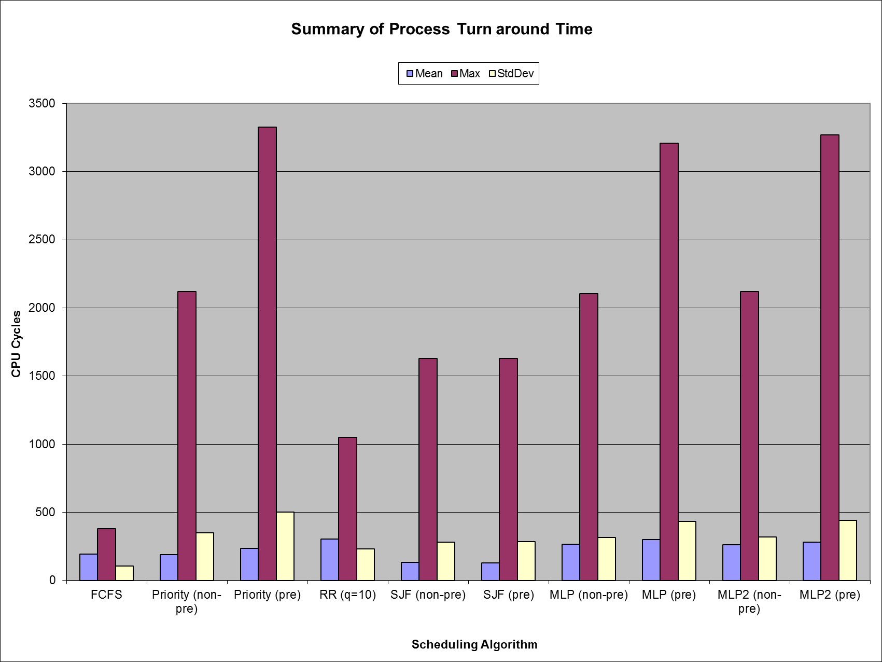

Jonathan Masukawa (33128396) Yan Zhao (31018809) Group #32

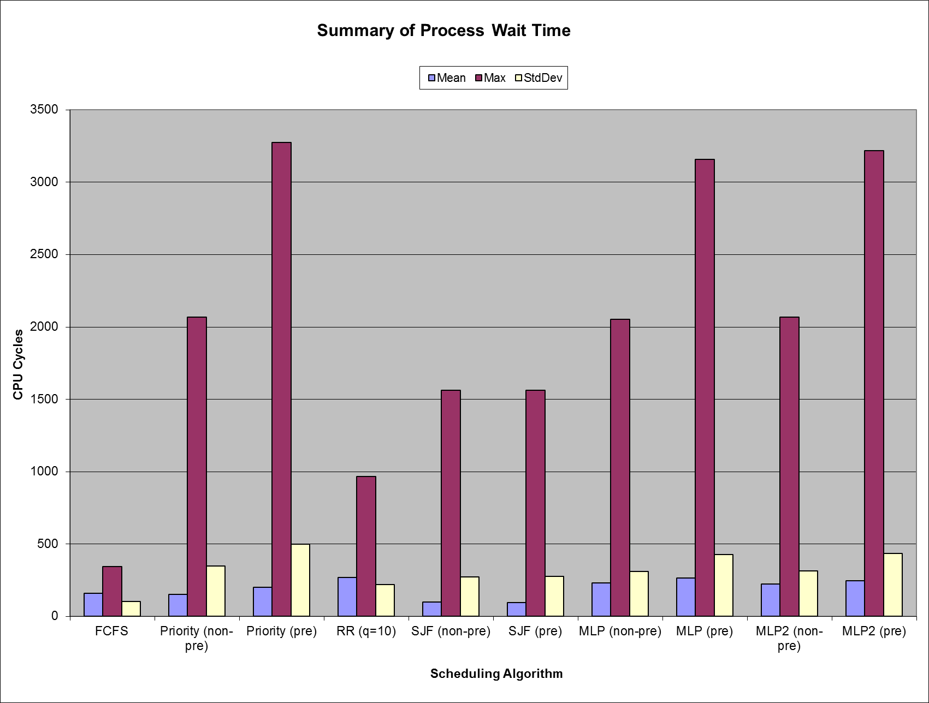

Jonathan Masukawa (33128396) Yan Zhao (31018809) Group #32

